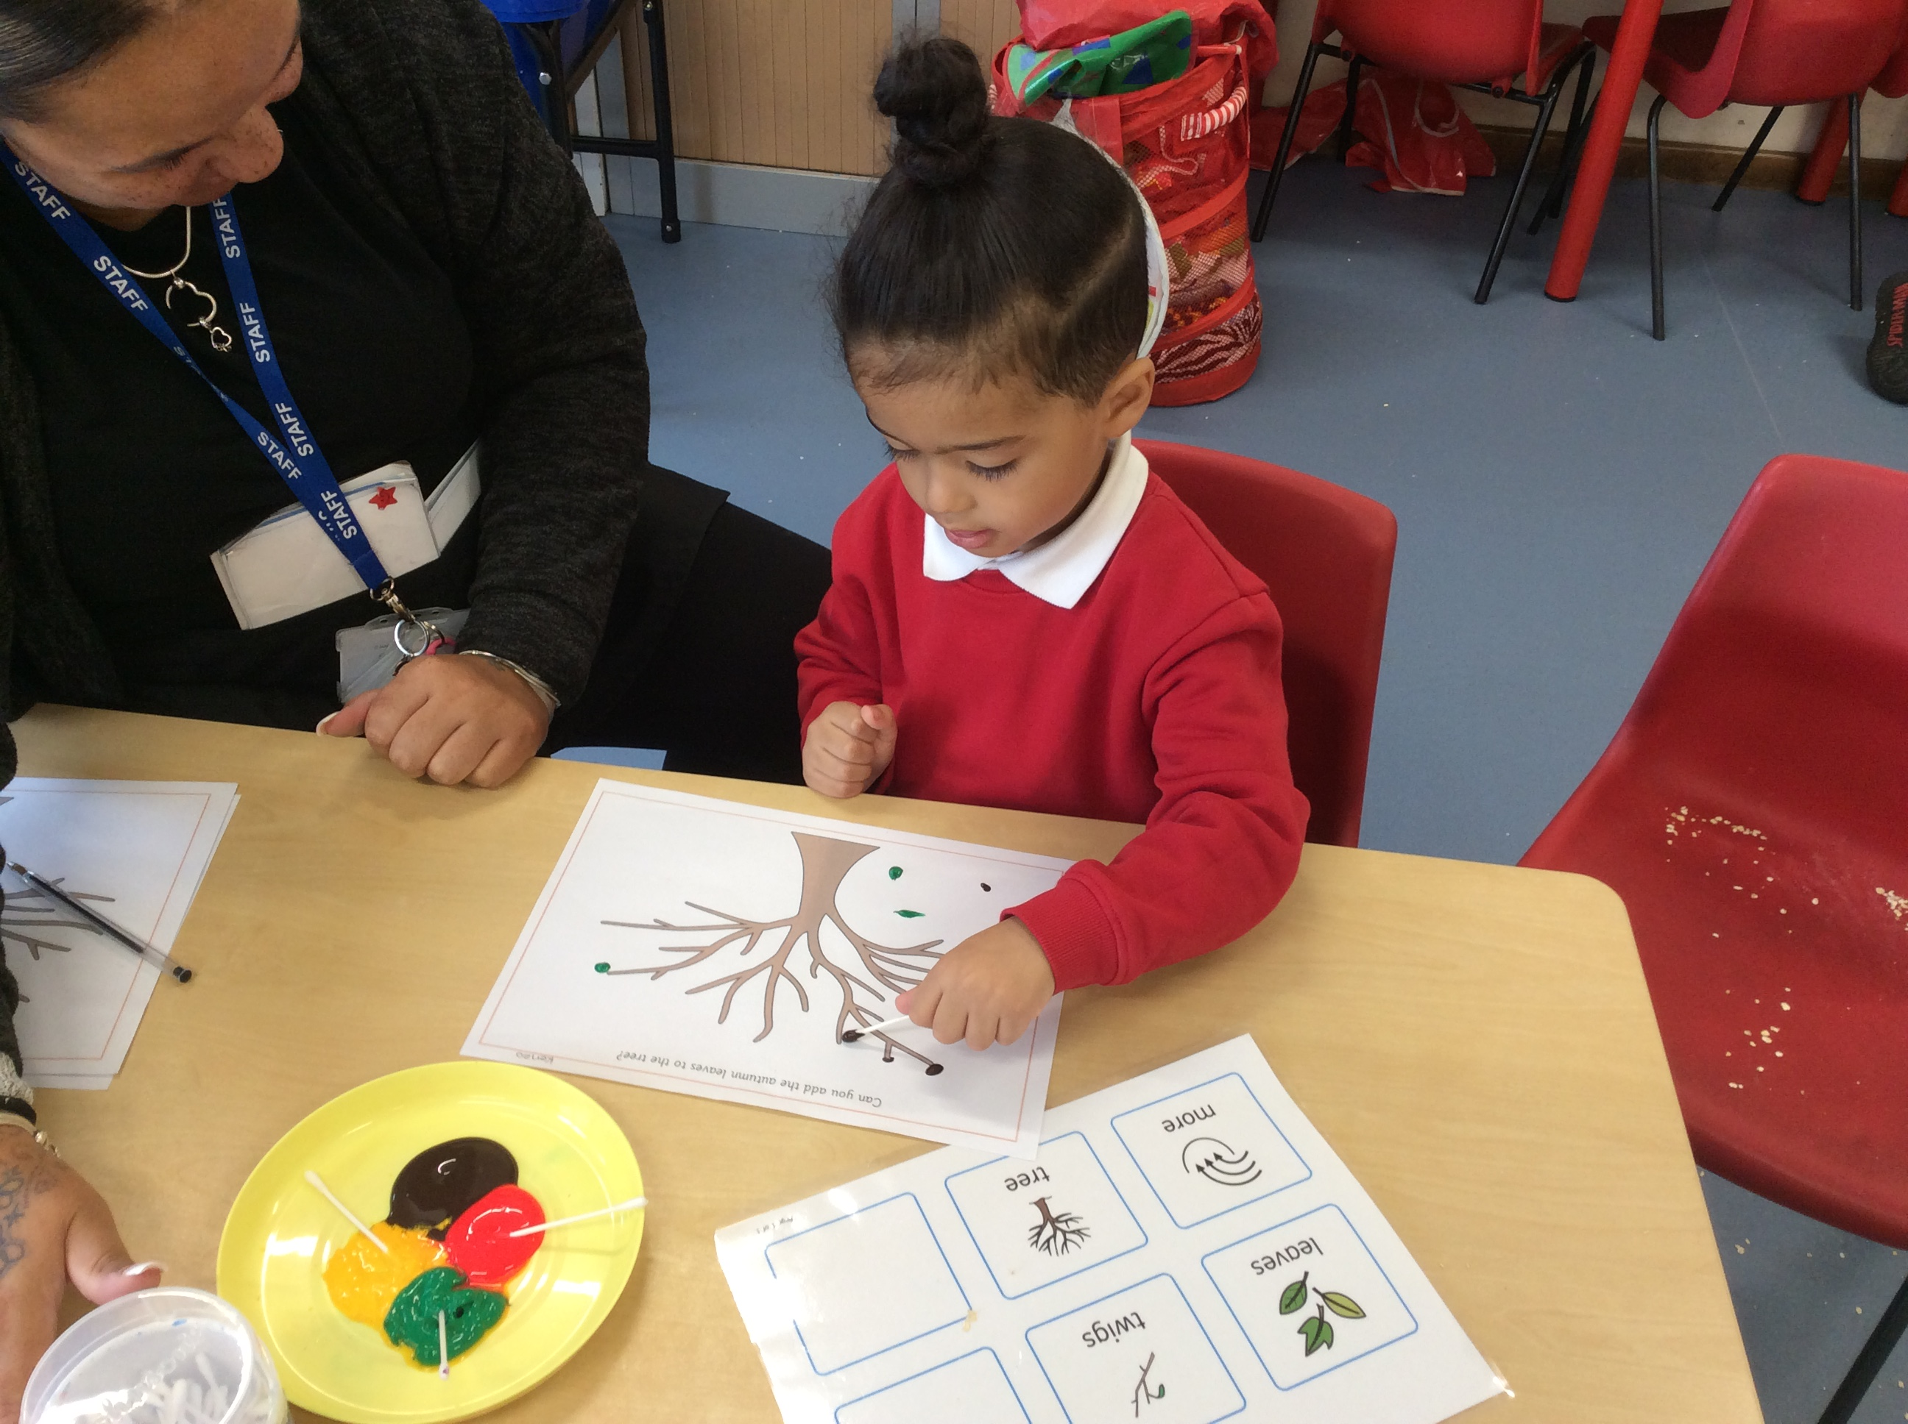

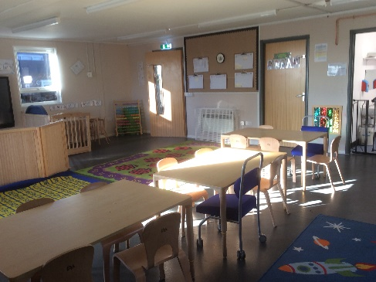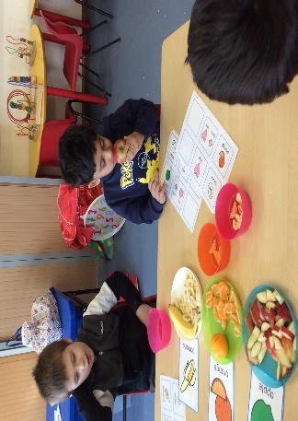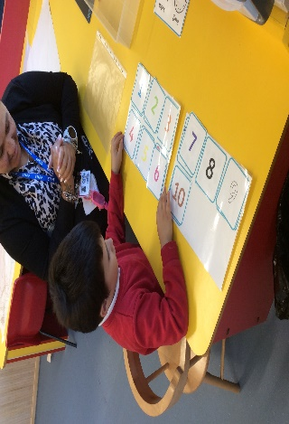

Alumwell Infant School
Across school
Communication in print used across school
- Timeline
- Now and next board in Reception (additional )
- Lanyards- choice and instruction
- Colourful semantics for adapted work
- Interventions using In print
- ALD boards in all classes
- Specific ALD boards relating to targets or need
- Support plans through Insight
- Attention bucket for specific children
- Core program for specific children
- Social stories
- Hearing impaired trained staff
- Equipment for physical needs / trained staff
Rainbow room
- Timeline
- Now and next board
- Lanyards- choice and instruction
- Interventions using In print
- Specific ALD boards relating to targets or need
- Makaton
- Intensive interaction
- Objects of reference
- Core word Program
- Assessment for core word
- Planning through ‘Sensory Classroom’
- Targeted Speech and language activities
- Insight support plans
- Insight tracking
- Bespoke environment based on specific needs of the children
- Sensory room
- Tiered workstations
- Tac Pac
- Weekly assessment recording boards
- Attention bucket
- Free flow VIP
- Fizzy kids
- Oral toys
- Gestalt language activities
- Time out area
- Forest school
- Adapted White rose maths
- Adapted RWI
- Word First
- Cause and effect activities with ALD
- Social stories
- Sensory stories
- Pragmatics
- Personalised snack time

Alumwell Infant School gives children
the POWER to succeed. We believe in
being a school with high aspirations for
all, where
“We learn, we grow, we achieve”
Focus this Year 2025 -26

- Core word program and assessment
- Sensory classroom planning implementation and assessment
- Update disability and access Policy

SEND
Provision
Training
- Gestalt language acquisition
- Attention bucket for new rainbow staff
- Weekly Staff meetings
- Provision mapping on Insight
- Risk Assessments
- All relevant Safeguarding training
- Manual Handling
- VI trained staff including Braille
Extra / Additional Provision and Support
- Monthly SEND Parents Coffee Morning
- Autism Awareness Day (June) Charity fundraising, whole school assembly and parent coffee morning
- Special Information Assemblies for children
- Additional adult support at Lunchtime
- Work with external agencies (please see list)
- Specific arrangements for when attending trips/visits

